HAZMAT 2024
22 & 23 May 2024, Crowne Plaza, Stratford-upon-Avon

About the Event

NCEC’s Hazmat conference is the ultimate forum for Hazmat Professionals to share experiences and gain knowledge with like-minded professionals working in the chemical incident industries.

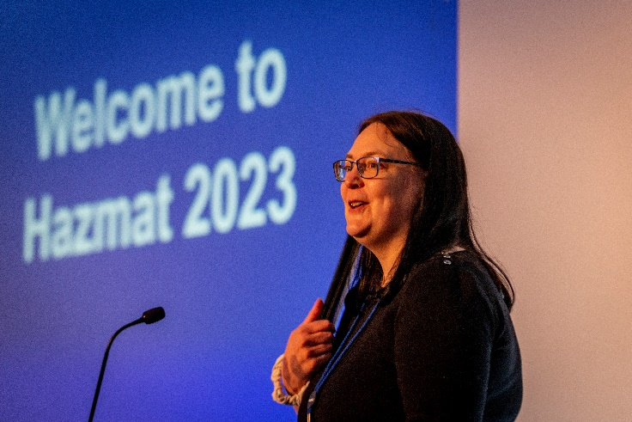
Now in its 15th year, the event draws upon the knowledge and experience of a broad range of hazmat professionals and industry leaders, as well as NCEC’s own emergency responders and experts. Bringing together international speakers from across sectors, delegates will benefit from world-standard presentations, case studies and practical, hands-on workshops in a friendly and welcoming environment.
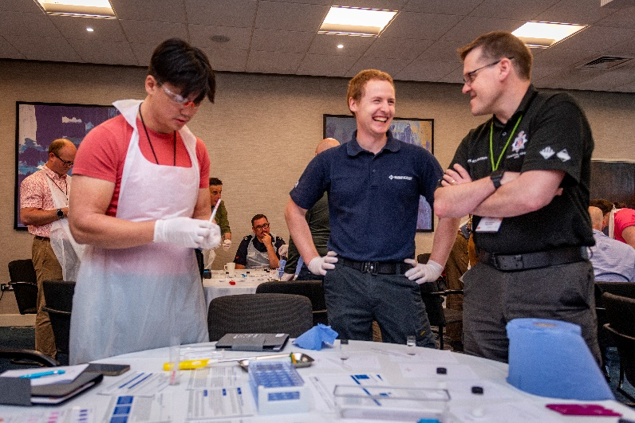

Using delegate feedback gathered at previous events, the format for Hazmat 2024 will again incorporate interactive syndicate exercises and workshops on a cross-section of subjects as part of this two-day conference. We will be encouraging speakers to include practical elements and group interaction where relevant. Sessions will also cover a cross-section of subjects as we look to increase multi-agency representation. Delegates will have the opportunity to tailor their experience by registering for specific workshops once the workshop programme has been finalised. Presentation and workshop topics and speakers are expected to include:

- Case studies | - High risk low frequency events
- Field expedient decontamination | - Alternatively powered vehicles

We are currently reviewing the programme for 2024, so if you have a case study you would like to share or a suitable topic to present on, please contact us as soon as possible with an outline.

Why should I attend?

Hazmat professionals need to keep up to date with hazardous materials response, chemical exposure monitoring, emergency planning, developments in legislation, future technologies, and learn lessons from past experiences. The Hazmat event is the best opportunity to gain a wider understanding of these issues, and more importantly, practical ways to address them.

All the subjects covered are relevant to people involved in chemical incident response and the setting provides a great opportunity to question and discuss content both in the forum and informally one-to-one. Delegates are drawn from fire services, police forces, ambulance services, the MOD, chemical industry, and bodies such as the Environment Agency, Public Health England and the Met Office.

Don’t just take our word for it, these are comments from previous delegates.

“Excellent choice of workshops, good info to guide procurement, policy & training in the future.”
“An exceptional event for like-minded people sharing experiences and emerging issues.”
“Best single point source of information for Hazmat professionals”
“Most relevant event in the sector”
“Excellent two days…again. Well done”

Delegate fee

The delegate fee will entitle you to:
- attendance on both days of the conference on 22 & 23 May 2024
- lunch and refreshments on both days of the conference
- single room bed & breakfast accommodation at the venue hotel for the night of 22 May 2024
- attendance at the conference dinner on 22 May 2024
- delegate pack including speaker presentations

Delegate rate:
Standard rate (1 January 2024 onwards) = £930 +VAT

If you wish to attend, please complete the delegate registration form overleaf or visit our website at
www.hazmatevent.co.uk. Exhibition and sponsorship packages can also be found on the website.

Hazmat 2024 Delegate Registration Form

Registration will only be accepted with full payment. Payment must be made by BACS transfer, credit or debit card and cannot be taken on the day of the event. Confirmation details will be sent by return email and a VAT invoice will be provided upon receipt of payment. Incomplete forms will not be accepted. Ricardo regrets it cannot give refunds due to cancellation but is able to accept substitution at short notice. Full terms and conditions are listed on the website www.hazmatevent.co.uk

Delegate Details
Title (Dr, Mr, Mrs, Ms, Other) |  |  |  |  |  |  |  |  | Organisation
First Name |  |  |  |  |  |  |  |  | Position
Surname |  |  |  |  |  |  |  |  | Address
Telephone
Fax
Email
Website |  |  |  |  |  |  |  |  | Post Code
Special dietary requirements
How did you hear about the event? |  |  |  |  |  |  |  | Choose an item.
Additional Delegate Names |  |  |  |  |  |  |  | Please complete the table overleaf
Signature

Delegate Fee
Item | Cost | No. required | Total Cost
Standard rate (payable after 01.01.24) | £930 + VAT |  | £
Number of delegates attending dinner on 22 May | Included in Delegate fee |  | -
Number of delegate bedrooms required for 22 May | Included in Delegate fee |  | -
Additional accommodation for 21 May (B&B) | £105 + VAT |  | £
VAT at 20% |  |  | £
Amount to pay including VAT |  |  | £

Payment Details (please tick payment method)
PO number
(NB Invoices will be issued with 30-day payment terms, payment to be made to account shown below)
BACS transfer (invoice will be issued with no PO number shown)
Lloyds TSB Bank Account number: 00816429 Sort Code: 30-00-01
Swift Code: LOYDGB21017 IBAN: GB84 LOYD 3000 0100 8164 29
Credit or Debit card – please email hazmat@ricardo.com to request a credit card payment form

Please complete and return this form, with full payment, to: NCEC Events Manager, Ricardo, Gemini Building, Fermi Avenue, Harwell, Oxon, OX11 0QR, UK. Tel: +44 (0)1235 753000, Fax: +44 (0)1235 753656, Email: hazmat@ricardo.com

Additional Delegate Details
Delegate 2
First Name | Surname |  |  | Email | Position
Special dietary requirements
Delegate 3
First Name | Surname |  |  | Email | Position
Special dietary requirements
Delegate 4
First Name | Surname |  |  | Email | Position
Special dietary requirements
Delegate 5
First Name | Surname |  |  | Email | Position
Special dietary requirements
Delegate 6
First Name | Surname |  |  | Email | Position
Special dietary requirements

