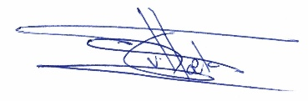

Tristan van Hoek
Regional Director Europe
Direct: +31 (030) 7524 700
Email: tristan.vanhoek@ricardo.com

