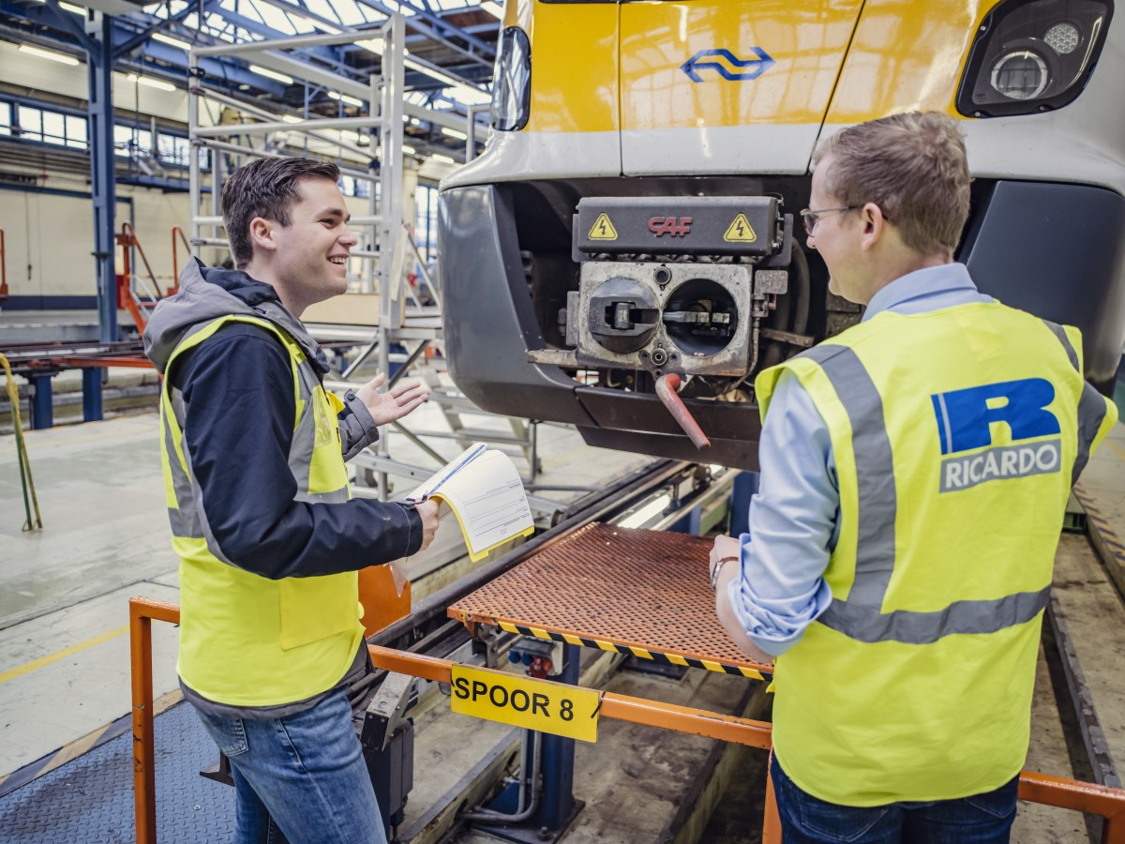

Annual report CO2 Performance Ladder 2024

In accordance with manual version 3.1

Date: 26th of May 2025

Reference:

Version: 3.0

Versie: <VERSIE>_ <CONCEPT>

Document history and authorization

|  |  |  |
| --- | --- | --- |
| Version | Date | Changes |
| 1.0  2.0 | 19-02-2025  08-05-2025 | First version  Second version, different changes after internal assessment |
| 3.0 | 26-05-2025 | Calculation based on emission factors of 2024 |

Created by: Daniëlle Keller

Signed: DK-009-023Y8637 Date: 26 th of May 2025

Peer review by: Marco Slotboom

Signed: MS-057-043Q5537 Date: 27th of May 2025

Release by: Tristan van Hoek

Signed: TH-193-036W7813 Date: 27th of May 2025

Distributielijst

|  |  |  |  |
| --- | --- | --- | --- |
| Name | Organisation | From (Version) | To (Version) |
|  |  |  |  |
|  |  |  |  |
|  |  |  |  |
|  | | | |

This document was prepared for the CO2 Performance Ladder. The information herein is confidential and shall not be divulged to a third party without the prior permission of Ricardo Nederland BV.

Ricardo plc, its affiliates and subsidiaries and their respective officers, employees or agents are, individually and collectively, referred to in this clause as the ‘Ricardo Group’. The Ricardo Group assumes no responsibility and shall not be liable to any person for any loss, damage or expense caused by reliance on the information or advice in this document or howsoever provided, unless that person has signed a contract with the relevant Ricardo Group entity for the provision of this information or advice and in that case any responsibility or liability is exclusively on the terms and conditions set out in that contract.

**© Ricardo plc 2025**

**Contents**

1. Introduction 4

2. Ricardo and CO2 Performance Ladder 5

**2.1** **Scope report and period** 5

**2.2** **Responsible person** 5

3. The organisation 6

**3.1** **Ricardo plc** 6

**3.2** **Vision and Purpose** 7

**3.3** **Strategy** 7

4. Method and scope 8

**4.1** **Method** 8

**4.2** **Organization description and environment** 10

**4.3** **Organisational Boundary (the scope)** 10

**4.4** **Organisational Boundary accountability** 10

**4.5** **Award advantage** 11

5. Size of Ricardo Nederland and choice relativity 12

**5.1** **Size** 12

6. CO2-footprint 2024 15

**6.1** **CO2-footprint** 15

**6.2** **Direct CO2-emissions** 16

**6.3** **Indirect-emissions** 16

7. Progress, trends and targets from 2012 18

**7.1** **Trends over the years** 18

**7.2** **Goals, progress and conclusion** 20

**7.3** **CO2 Performance Ladder from level 3 to level 5** 21

**7.4** **Progress on the measures and actions** 21

**7.5** **Supplementing opportunities for 2025** 22

8. Reporting in accordance with NEN-ISO 14064-1 23

9. Literature 24

**Bijlagen** 25

1. **Introduction**

We are committed to managing our environmental footprint and reducing it to a minimum, as well as ensuring that our services have a positive impact on society and the communities where we are based.

Ricardo already measures and discloses elements of its impact on the environment, by greenhouse gas emissions inventory reporting.

Ricardo has the following vision regarding hybrid working:

*“We are all individuals who together form our wonderful company. Our strength and added value for our customers lies in working together and sharing knowledge. We strengthen each other and that is why we need each other! The Management Team would like to meet you at the office. It is your own responsibility when you work in the office and you pay attention to your position and / or the project you are working on. You will agree on this with your manager. Together we form Ricardo, so as far as we are concerned, no one works completely from home. We are setting up our office on the Daalsesingel for this, and Ricardo also supports in setting up a good home workplace. In the coming period we will try, discover and experiment what this means for ourselves as a team and individually. In any case, we will be there at those times when our work, the customer or the organization requires it.”*

Our digital-first strategy enabled us to deliver innovations such as virtual certification, remote audits and inspections. Together with the use of virtual conferencing tools, we have been able to use this approach to continue our business processes largely unimpeded.

Ricardo Nederland B.V. wants to be corporate social responsible and as such take the surroundings and the environment into account. A valuable indicator for these aspects are CO2 emissions. These provide insight into the current state of affairs within the company and the possibility to measure changes in the future.

Our responsible business framework covers a broad range of environmental, social and governance (ESG) topics as they relate to Ricardo and to our clients, and links directly to the United Nations’ Sustainable Development Goals (SDGs), industry standards, frameworks and legislation, including Global Reporting Initiatives, International Sustainability Standards Board, and CDP see the Ricardo plc Annual Report & Accounts 2023/24 pages 44-74.

Specific Ricardo Nederland B.V. ESG information is published on <https://www.ricardo.com/en/who-we-are/governance/policies/co2-prestatieladder>. In addition, Ricardo Nederland has a policy statement, see Appendix A.1.4.

In July 2016 Ricardo Certification B.V. was established and all activities in the field of testing and certification have been incorporated into this. The technical consultancy activities fall under Ricardo Nederland B.V. Both B.V.’s are included in this report and in the associated 2024 footprint.

1. **Ricardo and CO2 Performance Ladder**
   1. **Scope report and period**

This report provides insight into the CO2 emissions of Ricardo Nederland B.V. and Ricardo Certification B.V., both hereinafter referred to as Ricardo Nederland. It concerns the direct and indirect emissions that are emitted by the activities of both B.V.’s. In addition, this report describes Ricardo Nederland ambitions to limit CO2 emissions in the future. The report describes the CO2 emissions from 2024, which consist of scope 1, 2 and also scope 3 emissions.

As of 2017, scope 1 includes the consumption of lease cars in liters. The electrical part is processed in kWh in scope 2, but because the hybrid cars are not equipped with charging cables, the usage in 2024 is zero. The rented cars are also processed in scope 1 on the basis of kilometers driven.

The report is based on the Dutch standard for Greenhouse Gases part 1 (NEN-ISO 14064-1) and follows section 7.3.1 of this standard. That is why a cross-reference table has been included in the last chapter. In addition, in some cases, reference is made to the CO2 Performance Ladder and the SKAO manual. The report uses the emission factors of the CO2 Performance Ladder in accordance with the SKAO manual version 3.1 and which are published on https://CO2emissiefactoren.nl/.

The financial year at Ricardo Nederland runs from July 1 to June 30. However, this report is based on a calendar year (January 1 to December 31, 2024).

* 1. **Responsible person**

Tristan van Hoek, Regional Director Europe and MT member, is responsible for this report and is internally supported by Marco Slotboom, HSEQ-Advisor. Every year a report is made on the previous calendar year. Every six months, in January and July, Daniëlle Keller, Facility & Environment Coordinator, requests information from various parties to determine the CO2 footprint. Marco Slotboom, HSEQ-Advisor, performs the calculation and Daniëlle Keller, Facility & Environment Coordinator reviews the calculation. The Annual Report and communication is written by Daniëlle Keller, Facility & Environment Coordinator and reviewed by Marco Slotboom, HSEQ-Advisor. During these processes also the necessary actions are addressed to realize the planned objectives.   
  
Daniëlle Keller, Facility & Environment Coordinator established and implement the communication plan, see also A.1.6. For the chain initiatives Martijn Wolf is the coordinator and the necessary budgets are agreed with the Team Manager, HR, Finance and ICT.   
  
In the above mentioned activities the PDCA-circle is integrated.

1. **The organisation**
   1. **Ricardo plc**

We are Ricardo. A global consultancy enabling the clean energy future by delivering strategic, environmental and engineering solutions that intersect the global transport, energy and climate agendas. We strive to create a safe and sustainable world by enabling our clients to solve the most complex and dynamic challenges. Our ambition is to become a global leading strategy and engineering consultancy in environmental and energy transition solutions. While being led by our values: Create together Be innovative Aim high Be mindful (source: Ricardo plc Annual Report & Accounts 2023/24).

* + 1. **Ricardo Clean Energy & Environmental Solutions (CE&ES)**

With effect from 1 July 2023, the Rail and Energy & Environment business units merged together to Clean Energy & Environmental Solutions (CE&ES).

Rail is one of the “Practices” within CE&ES and is a global consultancy and offers the rail industry a range of technical services. With our extensive knowledge and know-how of the most critical and complex technologies in the industry, we provide our customers - carriers, manufacturers, maintenance companies, infrastructure operators, investors and regulators - with specialized technical support. We help our customers to manage risk, reduce costs and improve performance.

* + 1. **Ricardo Rail in Utrecht**

Ricardo Rail in Utrecht is a leading consultancy with more than **154** specialist rail engineers. Our areas of expertise include the purchase, maintenance, performance improvement and functional safety of trains, trams, metros and rail infrastructure.

Ricardo Rail in Utrecht is represented by two companies:

Ricardo Nederland B.V. and Ricardo Certification B.V. both of which fulfill an important function in the European rail industry:

* Ricardo Nederland B.V. provides consultancy services in the field of Rolling Stock and Signaling & Infrastructure. It concerns high-quality technical advice in the field of the purchase, maintenance and performance improvement of trains, trams and metros, the rail infrastructure and the interaction between them.
* Ricardo Certification B.V. is a separate and independent B.V. and includes all testing and certification activities and is accredited to perform a wide range of specialist testing and certification activities.

* 1. **Vision and Purpose**

“Our vision is to create a safe and sustainable world”. We are building One Ricardo to create value and deliver our vision.

“Our purpose: Enable our clients to solve the most complex and dynamic challenges”.  
(source: [Ricardo Annual Report](https://www.ricardo.com/en/investors/results-centre/2023-24/annual-report-2023-24))

* 1. **Strategy**

“Our strategy is clear: we are on a transformation journey to become a global, world-leading strategic and engineering consultancy in environmental and energy transitions. And this has been a year of progress, as we firmly embed our strategy across Ricardo and focus on execution as we accelerate our impact in FY 2024/25.” (source: [Ricardo Annual Report](https://www.ricardo.com/en/investors/results-centre/2023-24/annual-report-2023-24))

CREATE TO

1. **Method and scope**

A first step is to gain insight (angle A) into the current energy flows. The method of the emission inventory calculation for Ricardo Nederland for 2024 (general inventory, data, CO2 footprint, emission factors, supporting documents, building, passenger transport (rental cars and lease cars), business travel, commuting, waste, paper consumption, electronics) corresponds to the method of the first reference year 2012.

For the calculations of 2024 data the new reference year 2022 has been used, although for insight also the data from 2012 will be listed. The calculations can be found in Work file CO2 footprint 2024, hya 878277 and in the document Reinvent energy data monthly export, hya 824716 the energy and gas use can be found. The scope classification in accordance with the GHG protocol method has been used.

The uniform Dutch list of emission factors from SKAO was used. (Emission factors SKAO manual, version 3.1, available at <https://CO2emissiefactoren.nl/>). The first paragraph describes the method for mapping the most important energy flows. Subsequently, the demarcation is described in section two. The last paragraph describes the key figures and assumptions used. Every year the latest CO2 emission factors will be used in the calculation.

**Movement**

As per the 1st of January 2022 we moved to another building. Due to this movements there are changes in the calculation of the STEG.

* 1. **Method**

In this report the emissions (expressed in CO2) of Ricardo Nederland are analyzed. This is done on the basis of the CO2 footprint as described in NEN-ISO 14064-1. NEN-ISO 14064-1 distinguishes different types of CO2 emissions. To determine Ricardo Nederland CO2 footprint, three categories of CO2 emissions were used (see SKAO manual version 3.1).

The emissions are classified in three scopes:

- Scope 1: Direct CO2 emissions

- Scope 2: Indirect CO2 emissions

- Scope 3: Other indirect CO2-emissions

The scopes for the CO2 Performance Ladder have been slightly adjusted, so that 'fuel consumption for business traffic by private cars' and 'fuel consumption for business air traffic' belong to scope 2 instead of scope 3 as described in NEN-ISO 14064-1, see also table 4.1 and scope diagram 4.1.

In addition to CO2 greenhouse gases, according to Handbook 3.1, it is not mandatory to include other greenhouse gases, such as CH4, N2O and PFCs, and refrigerants. These are not included in the in the calculation.

* + 1. **General rules for the use of CO2 emission factors**

In order to determine the CO2 footprint of Ricardo Nederland, data was collected on the emissions from scope 1 and 2. These data and emission factors were then used to calculate the amount of CO2 emissions. The emission factors from the CO2 Performance Ladder have been used. The CO2 footprint includes the factors from scope 1 and 2, as used in the CO2 Performance Ladder.

2022 is taken as the base or reference year due to the movement to the Daalsesingel in Utrecht per January 2022.

Table 4.1. Category classification *upstream* en *downstream* scope 3 emissions conform GHG Protocol Scope 3 Standard

|  |  |  |  |  |  |
| --- | --- | --- | --- | --- | --- |
|  | **Upstream:** |  |  | **Downstream:** |  |
|  |  |
| 1. Purchased goods and services  2. Capital goods  3. Fuel and energy-related activities (not included in  scope 1 or scope 2)  4. Upstream transport and distribution  5. Production waste  6. ~~Passenger transport during working hours~~  ~~(Business Travel~~)  7. Employee commuting  8. Upstream leased assets | | | 9. Downstream transport and distribution  10. Processing of sold products  11. Use of sold products  12. End-of-life treatment of sold products  13. Downstream leased assets  14. Franchises  15. Investments | | |

Scope diagram

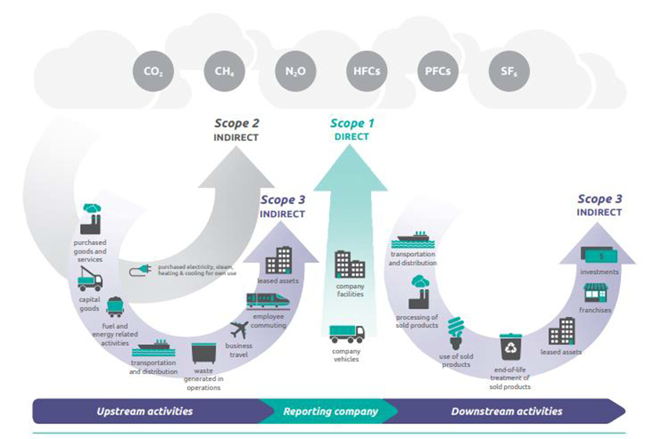

Scope diagram 4.1. The scope diagram of the GHG Protocol Scope 3 Standard

*The emission factors as included in the most recent version of the ‘CO2 Performance Ladder’*

*(SKAO manual version 3.1).*

* 1. **Organization description and environment**

The demarcation describes the organizational boundaries of Ricardo Nederland. In addition, the calculation method for determining the floor area is explained and the number of employees is determined.

* 1. **Organisational Boundary (the scope)**

In the context of the Greenhouse Gas protocol, or GHG protocol, the Organizational Boundary of Ricardo Nederland has been determined. In accordance with the manual 3.1. the GHG-protocol consists of several modules.

- Corporate Accounting and Reporting Standard: 2004.

- Corporate Value Chain (scope 3) Accounting and Reporting Standard: 2011 is "GHG Protocol

Scope 3 Standard”

- Product Life Cycle Accounting and Reporting Standard: 2011.

There are two options available to determine the scope. To determine the CO2 footprint of Ricardo Nederland the (operational) control approach was used, whereby Ricardo Nederland takes responsibility for 100% of the emissions for the business units, namely Ricardo Nederland B.V. and Ricardo Certification B.V., over which it has operational control. For a detailed description, see 3.1.2. Ricardo Rail in Utrecht.

The external stakeholders of the organization have been identified and this overview is updated annually. An overview is not given in this report, but this can be found in Hya 539751 - Context analysis Ricardo Nederland, where a distinction is made between the various aspects of the environment, quality, information security, occupational health, safety and energy.

* 1. **Organisational Boundary accountability**

Ricardo Nederland B.V. and Ricardo Certification B.V. are both located in the Netherlands (Utrecht). Both companies use the same office building with the same facilities. All input for the calculation of the CO2 footprint with regard to the office, air travel, car rental, data on the use of your own car, commuting and public transport use therefore concerns both of the above-mentioned companies.

Ricardo Nederland's financial year runs from July 1 to June 30. However, data based on a calendar year is used both for determining the annual footprint and for the annual reporting. As a result, this annual report contains data from the financial years 2023-2024 and 2024-2025.

We have analyzed our purchasing from 1 January to 31 December 2024 in accordance with the method of the CO2 Performance Ladder. In total197 providers have delivered to Ricardo Nederland B.V. of these, **11** organizations can be characterized as type A providers. 70% of all purchases are made with these providers.

In addition, we are dealing with two Ricardo entities, which should be characterized as C providers, namely Ricardo plc. and Ricardo Rail Ltd. These companies have been excluded from the scope because they are located outside the Netherlands and are not financially and operationally managed from the Netherlands.

The Organizational Boundary for this 2024 report has been set at: Ricardo Nederland from 1 January to 31 December 2024.

* 1. **Award advantage**

In 2021 Ricardo Nederland have started two projects with award advantage:

* TSI certificering (NoBo/AsBo) Opwaardering Maaslijn (project number 50560, Hya 802382) - ends at the end of 2027.
* AsBo/NoBo/ISA diensten t.b.v. PHS (project number 50582, Hya 802383) – continues through 2025.

In 2022 Ricardo Nederland has become a third project with award advantage:

* PHS Alkmaar – Amsterdam (project number 50668 Hya 844036) – ends 31st of December 2027.

The organization of the CO2 Performance Ladder for these 3 projects is the same as that of the entire organization. For this reason, the energy management action program, the steering cycle and the participation in initiatives have not been described again. The calculation of the footprint per project will be performed based on the turnover related to the total turnover from the organization. For these projects the calculation can be found in Hya 878277 and for these 3 projects the CO2 footprints are:

|  |  |  |  |
| --- | --- | --- | --- |
|  | 2024 | |  |
| **CO2 Footprint per project in Ton CO2** | **Jan-Jun** | **Juli-Dec** | **Total** |
| Project 50560 Scope 1 | 0,00 | 0,01 | 0,00 |
| Project 50560 Scope 2 | -0,01 | 0,03 | 0,02 |
| **Project 50560** | -0,01 | 0,04 | 0,03 |
|  |  |  |  |
| Project 50582 Scope 1 | 0,03 | 0,00 | 0,03 |
| Project 50582 Scope 2 | 0,10 | 0,02 | 0,12 |
| **Project 50582** | 0,13 | 0,02 | 0,15 |
|  |  |  |  |
| Project 50668 Scope 1 | 0,01 | 0,01 | 0,02 |
| Project 50668 Scope 2 | 0,04 | 0,08 | 0,12 |
| **Project 50668** | 0,06 | 0,09 | 0,15 |

The negative scope 2 in the first half of 2024 for project 50560 was caused by a financial correction.

1. **Size of Ricardo Nederland and choice relativity**
   1. **Size**

For the CO2 Performance Ladder, a distinction is made in size of companies, namely small, medium and large companies. This distinction is determined on the basis of the total CO2 emissions by the organization. Figure 5.1 shows the conditions per organization size.

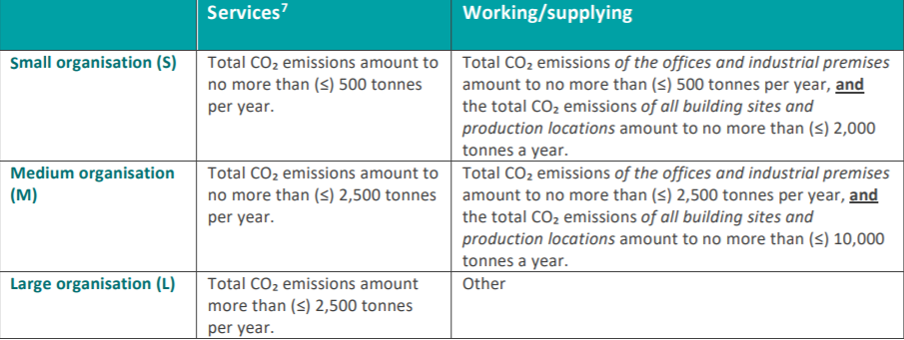

***Table 5.1: Size categories CO2 Performance Ladder (SKAO handbook version 3.1)***

Ricardo Nederland provides services and falls within the "small business" category. The total CO2 emissions of services provided amount to 102,8 tons of CO2 in 2024. Ricardo Nederland is granted exemptions from the audit checklist, because it belongs to this category.

* + 1. **Floor space Ricardo Nederland**

As per the first of January 2022 Ricardo Nederland and Ricardo Certification have moved to the Daalsesingel 51 and 51A in Utrecht. The offices are situated on the first floor and a measurement room and archive in the cellar. The Lettable Floor Space (LFS) for the first floor is 1710,37 m2 and the cellar 154,68 m2. However we have to count in accordance with the NEN2580 with the use of the general spaces for the first floor 275,99 m2and for the cellar 24,96 m2 for the cellar. Total first floor 1.988,36 m2and cellar 275,99 m2.Total is 2.165,97 m2.

* + 1. **Energy consumption per FTE**

Ricardo Nederland's turnover is not directly related to energy consumption and also the number of m2 cannot be directly influenced. This is the reason why the energy (CO2 ) consumption per FTE is shown.

* + 1. **Number of employees**

The number of employees in 2024 is calculated by the number of employees and the time period in which they were employed. In addition, the hiring of employees from secondment agencies and employment agencies is included. "Hiring" includes employees who work structurally at Ricardo Nederland; in day-to-day business no difference is made with permanent employees. These employees are also treated in the same way for the report as permanent employees. We calculate with the number of FTE instead of the number of employees. We use this number to calculate the CO2 footprint. For 2024 we assume 154,5 FTE.

* + 1. **Key figures & starting points for calculations**

This section describes the key figures and starting points for determining the CO2 emissions for scope 1, 2 and 3, thus the CO2 footprint of Ricardo Nederland. All calculations are registered in a collective Excel sheet, see Hya 878277. The results are presented below.

* + 1. **Office heat and energy consumption**

The heat and energy consumption of the entire office building is measured centrally by the owner and the total m2 of the office building is 8309,74 m2. As mentioned in paragraph 5.1.1 Ricardo Nederland uses 2.165,97 m2 and this is 26,1 % of the total m2 office building.

The total heat and energy consumption of the entire office building is 1.748 GJ and 603.605

kWh over 2024. As Ricardo Nederland uses 26.1% of the office building m2, the heat and energy consumption for Ricardo Nederland is 26,1% * 1.748 GJ = 456 GJ and 26,1% * 603.605 kWh= 157.332 kWh.

We obtain district heating by means of an installation based on the STEG technology, a combination of a gas and steam turbine system. Therefore the emission factor 25,05 kg CO2/GJ is used.

* + 1. **Office energy consumption**

Ricardo Nederland is located in an office building where electricity consumption is determined for the whole building. Using the data and the CO2 emission factor, a calculation has been made of the CO2 emissions from purchased electricity consumption.

From the first of January 2022 we are situated at the Daalsesingel 51 and 51A and the deliverer of our green wind energy is arranged by the tenant.

An overview is available of all electrical appliances in use, such as multifunctionals, screens etc. See Hya 560344.

* + 1. **Transport and mobility**

Ricardo Nederland uses both lease cars and rental cars, both of which fall under scope 1. Under scope 2, the use of private cars (declared kilometers) is processed. The fuel type and driven kilometers of the lease cars are known and the consumption in liters is calculated based on the WLTP-consumption figures from RDW. These are included in scope 1.  
  
The rental cars are also included in scope 1, however, use was made of driven kilometers and the emission factor for fuel type unknown. Although it has not been calculated exactly what the deviation is compared to the detailed calculation, it is assumed that the negligible deviation mentioned below also applies here.

Business trips with private cars are known on the basis of declared kilometers. For administrative reasons, but also in the context of GDPR, it has been decided to use the emission factor for fuel type unknown in this calculation as well. The calculation for 2017 has shown that there is only 0,06% deviation between the calculation using the different emission factors per fuel type and the calculation using the emission factor for fuel type unknown.

Air travel was also undertaken for the work of Ricardo Nederland. Air travel has been analyzed on the basis of the bookings. These bookings are made through FCM travel organization. We have also taken so-called intermediate stops into account. We calculate with kms (emission factor) based on travel distances, as provided by FCM.

Two sources are available for traveling on public transport for business purposes:

* Most Ricardo Nederland employees have a NS Business Card, which they use for commuting as well as for business and private travel. It is not possible to receive a detailed view per card due to privacy legislation.
* Employees who do not have their own NS Business Card can borrow an NS Business Card for business travel from Office Support.

The details of both types of Business Card are transparent and provided by NS. Also FCM and NS International provides us with international public transport data.

Because employees can also use the NS Business Card for private travel, the total number of kilometers for commuting is deducted from the total number of kilometers driven. Because, just like before 2020 due to COVID19, it was no longer possible to determine the exact business kilometers, the percentage of private versus business kilometers of 2019 (18%) has been used for the calculation for 2023. From NS the total driven kilometers are received quarterly and 18% from these kilometers are business train travel.

* + 1. **Biomass and CO2 removal**

Section 7 of NEN-ISO 14049-1 refers to CO2 emissions from the combustion of biomass and greenhouse gas removal. No biomass combustion took place at Ricardo Nederland, and no greenhouse gases (CO2) were removed.

* + 1. **Accuracy and uncertainties**

For the CO2 calculation of the use of a private car for business purposes, lease and rental cars, use is made of the actually declared or recorded kilometers.

Travel calculation is described in paragraph 5.1.7.

We have no insight in the actual kilometers flown between two places. Airline companies only state the total distance of the journey (ticket). We have therefore tried to arrive at a better approximation of the actual emissions.

To compensate for stopovers, the following adjusted calculation has been made:

• If the total distance divided by the number of routes is less than 700 km, the factor 0,234 is used.  
• If the total distance is between 700 and 2500 km, factor 0,172 is used.  
• At a distance of more than 2500 km, factor 0,157 is used.

In our opinion, this calculation gives the best approximation of the actual emission. A possible small error cannot be ruled out, but the effect will be very small due to the flight share on the total.

In conclusion, we can say that the total emission is not equal to the exact CO2 emission of Ricardo Nederland.

1. **CO2-footprint 2024**
   1. **CO2-footprint**

The total CO2 emission by Ricardo Nederland in 2024 is 102,8 tons of CO2. This is 0,67 tons of CO2 per FTE (average 2024: 154,5 FTE’s). The distribution of the emissions per scope is shown in table 6.1a and figure 6.1. The table (6.1b) shows the distribution across the scopes and sources.

|  |  |  |
| --- | --- | --- |
| **Distribution scope 1 and 2** | **CO2 [ton]** | **%** |
| Scope 1: Direct CO2-emissions | 18,4 | 18% |
| Scope 2: Indirect CO2-emissions | 84,5 | 82% |
| Total | 102,8 | 100% |

**Table 6.1a Distribution scope 1 and 2**

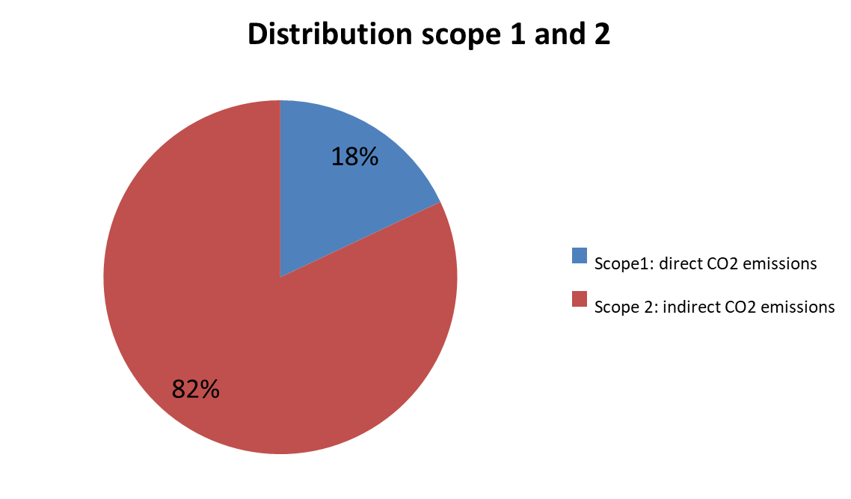

**Figure 6.1: Overview CO2 emissions from scope 1 en 2 divided (source Hya 903069)**

|  |  |  |  |
| --- | --- | --- | --- |
| **Activity** | **Scope** | **CO2 [ton]** | **%** |
| Scope 1: Direct CO2-emissions |  |  |  |
| * Fuel consumption for business traffic (lease and rental) | scope 1 | 18,4 | 18% |
| Scope 2: Indirect CO2-emissions |  |  |  |
| * Heat consumption (energy) | scope 2 | 11,4 | 11% |
| * Electricity usage | scope 2 | 0 | 0% |
| * Electricity lease car | scope 2 | 0 | 0% |
| * Business traffic private cars | scope 2 | 14,2 | 14% |
| * Air travel | scope 2 | 54,0 | 52% |
| * Business public transport | scope 2 | 4,9 | 5% |
| Total |  | 102,8 | 100% |

**Table 6.1b: Overview CO2 emissions from scope 1 en 2 (divided)**

* 1. **Direct CO2-emissions**

Direct emissions, scope 1, include fuel consumption for office heating and business traffic in lease and rental cars, in addition to coolants for cooling installations. The direct emission of coolants in cooling installations has not been taken into account; this is permitted according to the conditions of the CO2 Performance Ladder. There are no direct emissions for heating, because we use district heating. These are therefore reported under scope 2. See table 6.2 for the direct CO2 emissions.

|  |  |  |  |
| --- | --- | --- | --- |
| **Scope 1: Direct CO2 emissions** |  | **CO2 [ton]** | **%** |
| Scope 1: Fuel consumption |  |  |  |
| * Fuel consumption lease cars |  | 16,6 | 90% |
| * Fuel consumption rental cars |  | 1,8 | 10% |
| Total |  | 18,4 | 100% |

**Table 6.2: CO2 emissions Scope1 Direct Emissions**

* 1. **Indirect-emissions**

This section deals with scope 2: indirect emissions. This category includes warmth consumption, electricity consumption, fuel consumption “business travel private cars”, air travel and business public transport (train).

|  |  |  |
| --- | --- | --- |
| **Scope 2: Indirect emissions (verdeling)** | **CO2 [ton]** | **%** |
| * Heat consumption (energy) | 11,4 | 14% |
| * Electricity consumption | 0 | 0% |
| * Business travel electricity lease cars | 0 | 0% |
| * Business travel private cars | 14,2 | 17% |
| * Air travel | 54,0 | 64% |
| * Business travel public transport | 5,0 | 6% |
| Total | 84,5 | 100% |

**Table 6.3a: CO2 emission Scope 2 Indirect Emissies**

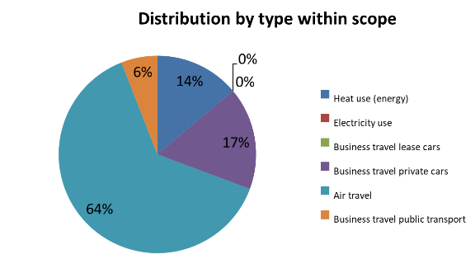

**Figure 6.3: Overview CO2 emissions from scope 2 (divided) (source 03-903069)**

* + 1. **Heat- and electricity consumption**

For the calculation of the heat and electricity consumption by Ricardo Nederland, use has been made of the data as described in 6.3.

|  |  |  |  |  |  |
| --- | --- | --- | --- | --- | --- |
| **Scope 2:  Heat and electricity** | **Type** | **Quantity** | **CO2-factor** | **CO2 [ton]** | **%** |
| Heat consumption | STEG | 456 | 25050 | 11,4 | 100% |
| Electricity | Wind | 157.332 | 0 | 0 | 0% |
| Total |  |  |  | 11,4 | 100% |

**Table 6.3b: CO2 emission Scope 2 Indirect Emissions: Heat and electricity consumption**

* + 1. **Fuel consumption air travel**

Ricardo Nederland also travels by plane for business travel. The results are shown in table 6.3d.

|  |  |  |  |  |  |
| --- | --- | --- | --- | --- | --- |
| **Scope 2: Details flight kilometers** |  | **km's** | **Factor (g/km)** | **CO2 [ton]** | **%** |
| Travel distance <700 km |  | 20.608 | 234 | 4,8 | 9% |
| Travel distance >=700 - <2.500 km |  | 145.976 | 172 | 25,1 | 47% |
| Travel distance >=2.500 km |  | 153.007 | 157 | 24,0 | 45% |
| Total |  | 319.590 |  | 54,0 | 100% |

**Table 6.3d: CO2 emission Scope 2 Indirect Emissions: air travel**

* + 1. **Business public transport (train, bus, tram, metro)**

Ricardo Nederland also travels by train for business traffic. The results are shown in Table 6.3e

|  |  |  |  |  |  |
| --- | --- | --- | --- | --- | --- |
| **Scope 2: Details train kilometers** |  | **km's** | **Factor (g/km)** | **CO2 [ton]** | **%** |
| Train type unknown |  | 276.900 | 3 | 0,8 | 17% |
| Train International |  | 33.324 | 17 | 0,6 | 11% |
| Bus, tram and metro |  | 47.359 | 75 | 3,6 | 72% |
| Train type unknown |  | 357.583 |  | 4,9 | 100% |

**Table 6.3e: CO2 emission Scope 2 Indirect emissions: business travel public transport**

1. **Progress, trends and targets from 2012**

This is the eleventh report and contains a representation compared to our first reference year 2012 and second reference year 2022.   
  
Because we have been moved to a smaller and more energy efficient office in January 2022, we use 2022 now as new reference year. Nevertheless the overview from 2012 until 2024 will be shown in the next paragraphs.

If necessary the new reference year will be recalculated on the basis of the SKAO manual version 3.1. The Annual Report for 2024 will be published on <https://www.ricardo.com/en/who-we-are/governance/policies/co2-prestatieladder> and on [Home - CO₂-Prestatieladder](https://www.co2-prestatieladder.nl/) (angle C).

* 1. **Trends over the years**

|  |  |  |  |  |  |  |  |  |  |  |  |  |  |  |  |
| --- | --- | --- | --- | --- | --- | --- | --- | --- | --- | --- | --- | --- | --- | --- | --- |
|  | CO2 [ton/jaar] | | | | | | | | | | | | | |  |
|  | 2012* | 2013 | 2014 | 2015* | 2016 | 2017 | | 2018 | 2019 | 2020 | 2021 | 2022** | 2023 | 2024 |
| Fuel consumption business travel | 8 | 6 | 0 | 16 | 38,1 | 51,8 | | 30,1 | 21,2 | 13,3 | 12,9 | 16,2 | 16,0 | 18,4 |
| Warmth consumption (energy) | 33 | 11 | 9 | 30 | 33,7 | 30,7 | | 30,5 | 30,2 | 28,2 | 24,0 | 14,3 | 10,5 | 11,4 |
| Electricity usage | 140 | 140 | 116 | 0 | 0 | 0 | | 0 | 0 | 0 | 0 | 0 | 0 | 0 |
| Business travel private cars | 62 | 57 | 60 | 51 | 99,2 | 29,2 | | 29,4 | 22,1 | 27,0 | 35,6 | 22,8 | 18,2 | 14,2 |
| Air travel | 169 | 142 | 141 | 111 | 107,7 | 135 | | 124,4 | 72,8 | 14,5 | 16,0 | 38,6 | 44,1 | 54,0 |
| Business travel public transport | 9 | - | - | 9 | 11,1 | 16,9 | | 2,8 | 3,5 | 0,3 | 0,2 | 0,6 | 1,6 | 4,9 |
| Total | 423 | 357 | 326 | 218 | 289,8 | 264,1 | | 217,2 | 149,8 | 83,4 | 88,7 | 92,5 | 90,4 | 102,8 |
|  | **CO2 [ton/fte]** | | | | | | | | | | | | | |
| Fuel consumption business travel | 0,04 | 0,03 | 0,00 | 0,08 | 0,17 | | 0,22 | 0,14 | 0,11 | 0,07 | 0,07 | 0,10 | 0,10 | 0,12 |
| Heat consumption (energy) | 0,17 | 0,06 | 0,05 | 0,14 | 0,15 | | 0,13 | 0,14 | 0,15 | 0,15 | 0,14 | 0,09 | 0,06 | 0,07 |
| Electricity consumption | 0,74 | 0,73 | 0,60 | 0 | 0 | | 0 | 0 | 0 | 0 | 0 | 0 | 0 | 0 |
| Business traffic private cars | 0,34 | 0,29 | 0,31 | 0,24 | 0,45 | | 0,13 | 0,13 | 0,11 | 0,15 | 0,21 | 0,14 | 0,11 | 0,09 |
| Air travel | 0,93 | 0,73 | 0,73 | 0,53 | 0,48 | | 0,58 | 0,57 | 0,37 | 0,08 | 0,09 | 0,23 | 0,27 | 0,35 |
| Business travel public transport | 0,05 | - | - | 0,04 | 0,05 | | 0,07 | 0,01 | 0,02 | 0 | 0 | 0 | 0,01 | 0,03 |
| Total | 2,27 | 1,84 | 1,69 | 1,03 | 1,30 | | 1,14 | 1,00 | 0,78 | 0,45 | 0,51 | 0,56 | 0,55 | 0,67 |

**Table 7.1a: CO2 emission compared per year**

*\* Start year 2012 and from 2015 based on SKAO manual version 3.0 and with addition of business public transport in   
 2012 and from 2015. From 2020 based on SKAO manual version 3.1.* *\*\* New reference year after moving to smaller office.*

*Note: Numbers are rounded and may differ slightly from the original footprint.*

**Absolute CO2 FTE**

|  |  |  |  |  |  |  |  |  |  |  |  |  |  |  |
| --- | --- | --- | --- | --- | --- | --- | --- | --- | --- | --- | --- | --- | --- | --- |
|  | **CO2 [ton/year]** | | | | | | | | | | | | | |
|  | 2012* | 2013 | 2014 | 2015* | 2016 | 2017 | 2018 | 2019 | | 2020 | 2021 | 2022** | 2023 | 2024 |
| Total | 423,1 | 355,3 | 324,6 | 217,7 | 289,8 | 264,1 | 217,2 | 149,8 | | 83,4 | 88,7 | 92,7 | 90,4 | 102,8 |
|  | **CO2 [ton/fte]** | | | | | | | | | | | | | |  |  |  |  |  |  |  |  |
|  | 2012* | 2013 | 2014 | 2015* | 2016 | 2017 | 2018 | | 2019 | 2020 | 2021 | 2022 | 2023 | 2024 |
| Total | 2,22 | 1,87 | 1,69 | 1,04 | 1,30 | 1,14 | 1,00 | | 0,78 | 0,45 | 0,51 | 0,56 | 0,55 | 0,67 |

**Table 7.1b: CO2 emission compared per year, see hya 878277 Work file CO2 footprint 2024**

*\* Start year 2012 and from 2015 based on SKAO manual version 3.0 and with the addition of business  
 public transport in 2012 and from 2015. From 2020 SKAO manual version 3.1.  
** New reference year after moving to smaller office.*

We have shown the trends in the table above and graph below.

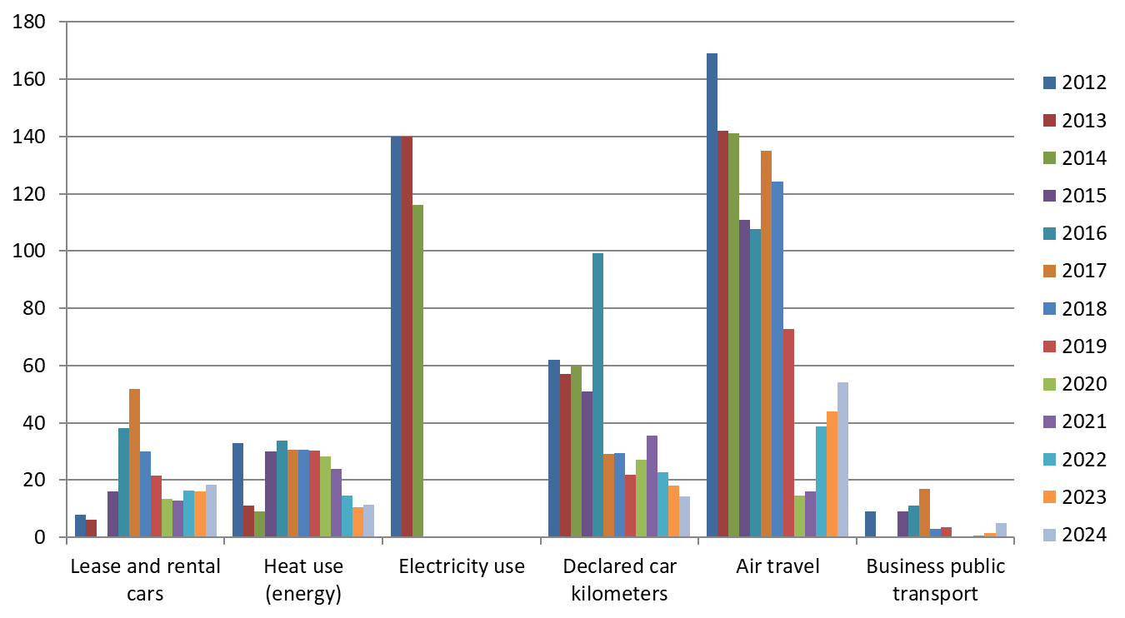

**Table 7.1c: CO2 emission trends based on table 6.1 b with emission factors 3.0 (except 2013 and 2014) and 3.1 from 2020. Business travel train added in 2015 and changed the first reference year 2012 and second reference year 2022 accordingly.  
  
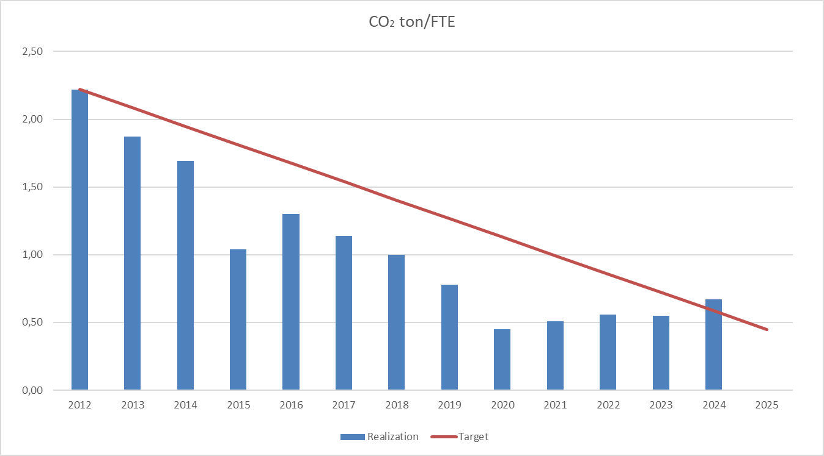  
Figure 7.1: Overview realization versus target CO2 ton/FTE, see hya 878277 Work file CO2 footprint 2024**

* 1. **Goals, progress and conclusion**

In response to the reference year 2022, a target for energy and CO2 reduction (approach B) has been formulated for the period 2022-2025.

*Ricardo Nederland's objective is to reduce CO2 emissions by 20% (measured per FTE) in the period 2022 - 2025.*

Compared to the start year 2012 this means a reduction from 80%, but because of the movement to a smaller and more efficient office the reference year has been changed to 2022.

The realization in 2024 for scope 1 and 2 have been respectively 18% and 82%. The targets for the distribution per scope up to and including 2025 has been respectively 15% for scope 1 and 85% for scope 2.  
  
Compared with 2023 we travelled more by train (54.184 km) and airplane (56.547 km). Therefore we see an increase on traveling by public transport with 3,4 CO2 ton and on traveling by plane of 9,8 CO2 tons.

From 2023 on we mention the international train travels separately from the national train travels and from 2024 we mention the public transport by bus, tram and metro separately.

The travel by cars (lease, rental and private) has been decreased by 1,7 CO2 tons.

From the beginning of 2022, the office is relocated to a smaller and more efficient building also with sun panels. The heating energy increased with 38 GJ and also the electricity increased with 6.280 kWh. Due to more tenants in the building the total usage of heat and electricity increased and therefore also we see an increase for Ricardo Nederland.

Table 7.2 shows a recalculation (SKAO Manual version 3.1) on emission factors 2024:

|  |  |  |  |
| --- | --- | --- | --- |
|  | **2022** | **2023** | **2024** |
| CO2 ton | 114,0 | 90,4 | 102,8 |
| CO2 Ton/FTE | 0,69 | 0,55 | 0,67 |

**Table 7.2 Realisation CO2 footprint**

If the actual (2024) CO2-emission factors are also use from the 2022 data the total would be 114,0 CO2 tons instead of 92,7 CO2 tons. Therefore we can conclude that against reference year 2022 we see an decrease of 11,2 CO2 tons and a decrease from 0,02 CO2 Ton/FTE.

Also for the period until 2025 the objective related to ‘Green Energy’ is to maintain the supply of electricity based on green wind energy and thus an emission factor of 0.

Based on the new 2024 CO2-emission factors the conclusion is that in 2024 the CO2 emissions per FTE have increase with 0,12 CO2 ton/FTE compared to 2023.

With the actual 2024 CO2-emission factors the objective for 2025 will be 0,55 CO2 Ton/FTE.

* 1. **CO2 Performance Ladder from level 3 to level 5**

In 2015, management decided to qualify Ricardo Nederland for level 5 on the CO2 Performance Ladder.

A qualitative and quantitative chain analysis (03-875717) has been carried out for 2024 to calculate the upstream emissions for requirements 4.A.1 and 5.A.1.

The scope 3 emissions top 5 consist of (in order of size)

|  |  |
| --- | --- |
| **Scope 3 emissions top 5** | **CO2 ton** |
| 1. Computer Services | 81,44 |
| 2. Hired staff | 60,78 |
| 3. Real estate services | 54,58 |
| 4. Specialized construction work | 16,42 |
| 5. Accounting and tax advices | 14,07 |
| Total | 227,28 |

In total scope 3 emissions are 253,8 ton CO2, so the above mentioned top 5 is about 70% of the total emissions. For more details about the qualitative and quantitative chain analysis see Hya (03-900605).

For scope 3 chain analyse and plans a reference is made to the documents: Hya 708248 – ketenanalyse (4.D.1) Ricardo Nederland, Hya 903258 - Strategie en PvA Ketenanalyse CO2-Prestatieladder 2024, Hya 903257 - Jaarverslag 2024 ketenanalyse CO2-Prestatieladder en Hya 903249 - Keten Initiatieven CO2-Prestatieladder verslag 2024. The qualitative progress on the chain analyses objectives can be found in the Hya 903257 - Jaarverslag 2024 ketenanalyse CO2-Prestatieladder (Voortgang en vervolgstappen). Quantitative progress is very hard to measure year-by-year progress because removing of diesel lines is a long term process. Sometimes this can take a decade.

* 1. **Progress on the measures and actions**

This section provides insight into how we performed in relation to the planning. Sometimes there is a reason for postponement, because resources or options are lacking. We have indicated this with additional information about the circumstances and, if possible, a new schedule. Our chain initiatives are published separately at <https://www.ricardo.com/en/who-we-are/governance/policies/co2-prestatieladder> and at the SKAO website (initiative D).   
  
The results for 2013 to 2024 can be found in appendix A.1.2. See A.1.5 for an analysis of the SKAO's List of Measures 2024. Progress achieved and actions taken within the chain in 2024 are documented in Hya 903249 – Keteninitiatieven CO2-Prestatieladder verslag 2024, see also above mentioned website.

* 1. **Supplementing opportunities for 2025**

• Active energy monitoring to detect high consumption by Hello Energy portal – Ongoing

• Due to partly working at home/office less travel, communication via teams for meetings   
 (Hybrid working) - Ongoing

• Monitoring energy, city heating, water use, paper use – Ongoing

• Certification for the CO2 Performance Ladder level 5 over 2024 – Ongoing

• Sustainable procurement – Ongoing

• Comply to ESG (Environmental, Social & Governance) standards – Ongoing

• Server room heat reduction – Research

• Action point internal audit: add references from datafiles to work file

• Action points internal audit: improvement of steering cyclus QMS in Annual Report

• Action points internal audit: improve overview objectives (main and sub) in Annual Report

1. **Reporting in accordance with** **NEN-ISO 14064-1**

The CO2 emission inventory report has been drawn up in accordance with the requirements of ISO 14064-1, section 9.3.1. In the table below, a cross table has been made of the parts from ISO 14064-1 and the entry in this file.

|  |  |  |
| --- | --- | --- |
| **ISO 14064-1 §9.3.1** | **Beschrijving** | **Vermelding** |
| A | Description of the reporting organization | Chapter 3 |
| B | Person or entity responsible for the report | §2.2 |
| C | Reporting period covered | §2.1 |
| D, E | Documentation of organizational and reporting boundaries, including criteria to define significant emissions | Chapter 4 |
| F | Direct GHG emissions | §6.2 |
| G | Treatment of biogenic CO2 emissions and removals | §5.1.8 |
| H | GHG removals | §5.1.8 |
| I | Exclusion of sources or sinks | Chapter 4 |
| J | Indirect GHG emissions | §6.3 |
| K | Base year | Chapter 7 |
| L | Changes and recalculations | Chapter 7 |
| M | Quantification approaches | Chapter 4 |
| N | Changes to methodologies | Chapter 4 |
| O, T | Emission or removal factors used | §2.1 |
| P, Q | Uncertainties | §5.1.9 |
| R | Statement in accordance with ISO 14064-1 | §2.1 |
| S | Verification | Chapter 8 |

**Table 8: Comparison ISO 14064 and report**

1. **Literature**

* Netherlands Standardization Institute (2007), NEN 2580, Surfaces and volumes of buildings - Terms, definitions and determination methods,<http://nl.wikipedia.org/wiki/Bestand:NEN_2580.JPG>The content of NEN 2580 is regularly revised; the latest version dates from 2007, supplemented in 2008 with a correction sheet C1 (NEN 2580:2007/C1:2008).
* Greenhouse Gas Protocol  
  Since the publication of Greenhouse Gas Protocol’s [Corporate Accounting and Reporting Standard](https://ghgprotocol.org/corporate-standard) (2004), [Corporate Value Chain (Scope 3) Standard](https://ghgprotocol.org/standards/scope-3-standard) (2011), [Scope 3 Calculation Guidance](https://ghgprotocol.org/scope-3-technical-calculation-guidance) (2013), and [Scope 2 Guidance](https://ghgprotocol.org/scope_2_guidance) (2015), there have been many important developments in greenhouse gas accounting and reporting. Among these are the Science Based Targets initiative (SBTi), the trend toward net-zero targets, mandatory climate disclosure regulations, use of the standards by thousands of companies, and academic research on their use and impact.  
  [www.ghgprotocol.org](http://www.ghgprotocol.org).
* Green Gold Label  
  [www.greengoldlabel.com](http://www.greengoldlabel.com)
* Netherlands Standardization Institute (2006). NEN ISO 14064-1:2006, Greenhouse gases —  
  Part 1: Specification with guidance at the organisation level for quantification and reporting of greenhouse gas emissions and removals, Delft.  
  NEN-EN-ISO 14064-3:2019 en NEN-EN-ISO 14064-3 specifies principles and requirements and provides guidance for verifying and validating greenhouse gas (GHG) statements. It is applicable to organization, project and product GHG statements. The ISO 14060 family of standards is GHG programme neutral.  
  [www.CO2emissiefactoren.nl](http://www.CO2emissiefactoren.nl) – calculating the CO2 emissions with the CO2 emission factors.
* CO2 Performance Ladder, generic manual V3.1 22 June 2020 of SKAO  
  [www.skao.nl](http://www.skao.nl).
* NEN-EN-ISO / IEC 17021-1: 2015 en Description: Conformity assessment - Requirements for bodies providing audit and certification of management systems - Part 1: Requirements

**Bijlagen**

**A.1.1 – Groencertificaat Nederlandse Zon**

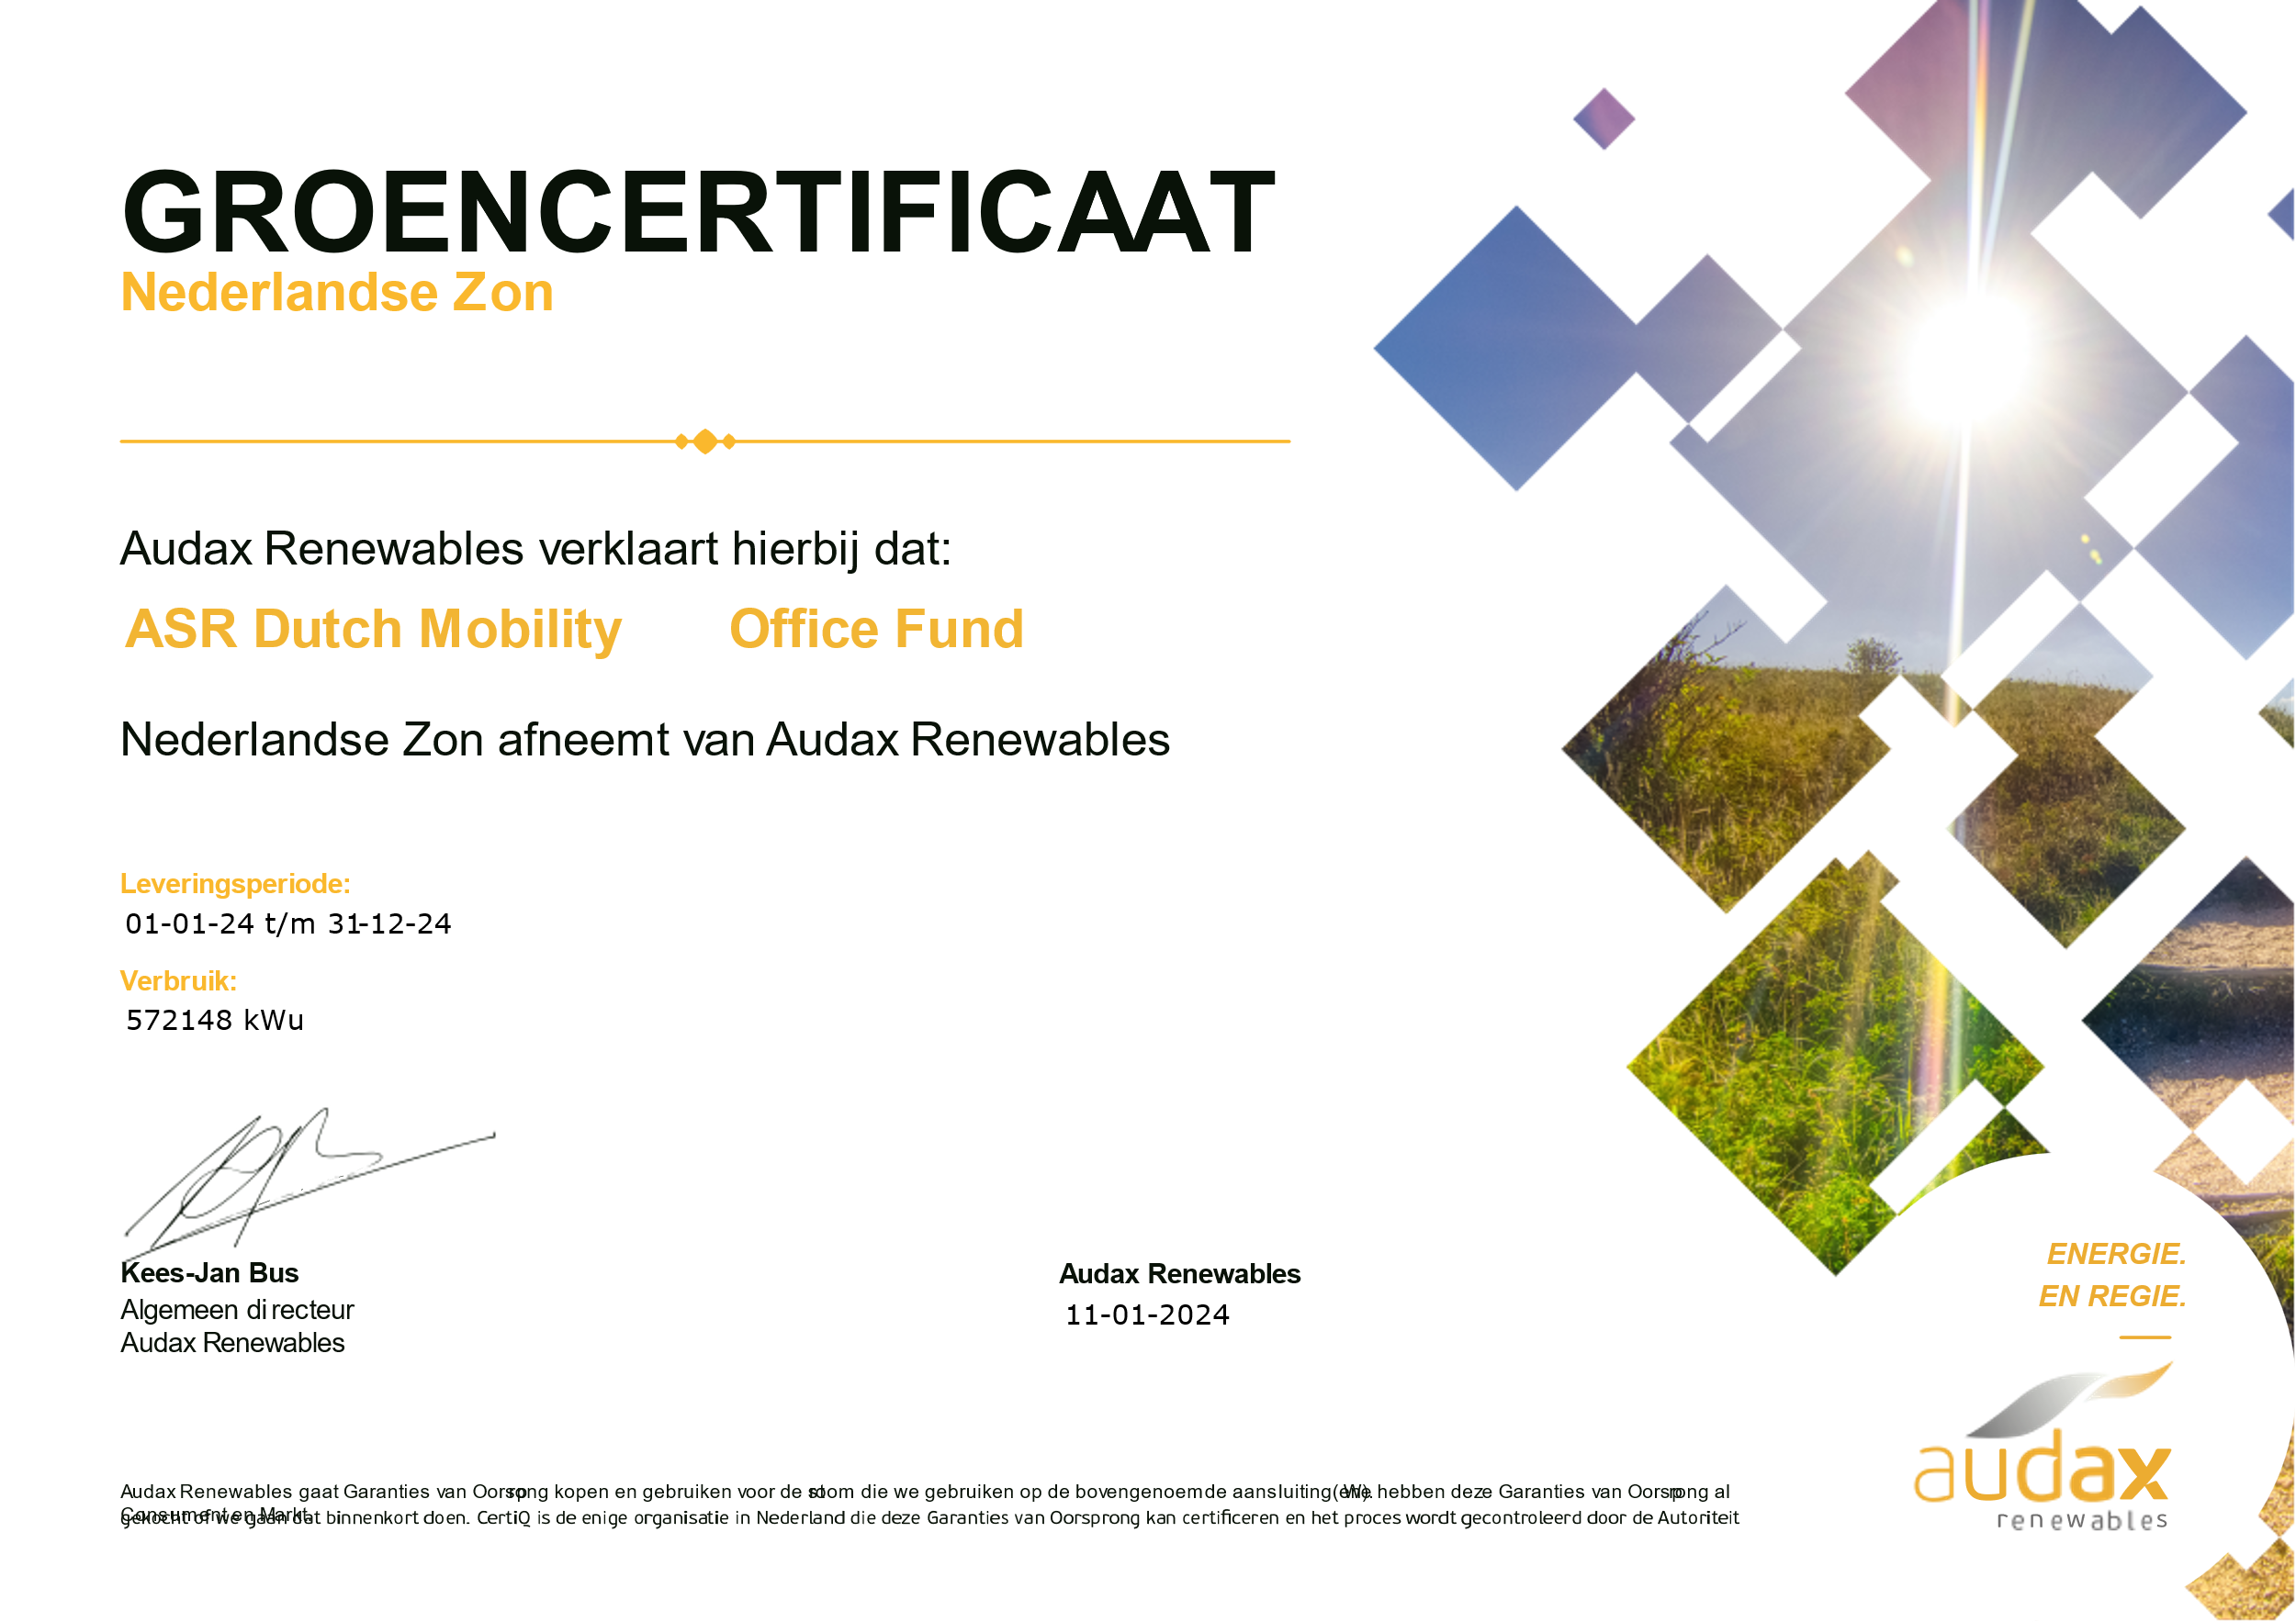

**A.1.2 Results 2013-2024**

**Results for the year 2013**

* Increase waste separation with separation of plastic and organic waste (realised according to plan)
* Continue separation of paper, residual waste, batteries and glass (realised on schedule)
* Awareness in cleaning of waste separation (realised according to plan)
* Awareness of and implementation by security for switching off the lights at the end of the day. (realised in 2013 ahead of planning)
* Digitizing the archive (realised by divestiture of external archive)
* Drawing up an energy balance / CO2 footprint 2012 and 2013 (realised according to plan)

**Results for the year 2014**

* Switch to green electricity. The green energy mix was realised as of May 2014 (however, this has been calculated as gray because we could not obtain the correct data in accordance with the NTA and the ladder and Dutch wind energy as of 1 November 2014).
* Digital monitoring of energy consumption. This is going well, insight via the Stedin portal. That is why we have also decided for this year to start reporting and processing on a calendar year and per month. Has been realised and remains to be a continuous process.
* Transparency in waste flows and making choices for further reduction and/or separation. This has been realised via WIAR and is part of scope 3 and at the moment we do nothing with it in terms of calculations.
* Verification of the prepared CO2 footprint reports by an external organisation will be realised in mid-2015. Was realised on May 1, 2015.
* Internal and external communication of our CO2 footprint and progress on measures can be further refined. Continuous point of attention.
* Certification for the CO2 Performance Ladder by an external organisation will be realised after verification in 2015. Was achieved on June 30, 2015.
* Turn off lighting at the end of the day (by security).
* It is known that employees from our organisation leave the lights on when they leave the building. This has already been communicated, of course, but we have identified that it is possible to prevent the lights from being on all night as well. That is why we will make agreements with security that they switch off the light that is still on. This allows us to estimate the savings. Expected savings based on internet sources: 1-5%. Unfortunately, this is not easy to measure. Update: Completed in 2014 and is still being continued.

**Results for the year 2015**

* Research into more environment energy/ CO2-friendly rental cars. This is an ongoing process in which we maintain contact with our supplier Avis.
* Maintain a green electricity contract and, if possible, switch to a better version of green electricity. Realised as of November 1, 2014.
* Drawing up an energy balance / CO2 footprint for 2014. Realised on April 17, 2015.
* Verification of the prepared CO2 footprint by an external organisation (delayed measure from 2014). Realised May 1, 2015.
* Internal and external communication of our CO2 footprint and progress on measures. Has been brought to the attention by the CSR communication plan and the Communication Manager.

Certification for the CO2 Performance Ladder by an external organisation (delayed measure in 2014). Completed June 30, 2015.

**Results for the year 2016**

* Maintain green electricity (wind energy) contract. Before October 2016. Realised.
* Analyze (2012-2016) and improve energy consumption and CO2 emissions in the next 5 years. Continuous.
* Drawing up an energy balance/ CO2 footprint for 2015. Realised in April 2016.
* Internal audit February/March 2016. Completed in April 2016.
* Internal and external communication of our CO2 footprint and progress on measures. Continuous.
* Transition to CO2 Performance Ladder level 5 with insight into quantitative and qualitative analysis, so that the reduction measures are determined aimed at the chain. Deadline May 2016. Realised.
* Drawing up the CO2 Performance Ladder for Ricardo Certificering B.V. May 2016. Realised.
* Reassessment for the CO2 Performance Ladder at level 5 by external organisation according to annual cycle, before 1 August 2016. Realised.
* Monitor, optimize and communicate the implementation of MS Lync so that a reduction target can be formulated for the coming years. Partly realised. MS Lync (now Skype) is used, but it is not clear how often.
* Investigate whether there are differences in airlines with regard to CO2 emissions. Deadline May 2016. Researched, but this has not led to concrete adjustments.
* Review lease contracts and enter into discussions with the lease company about possible CO2 reduction. It has been decided not to take any further concrete action on this.
* Checking which employees drive a lot of private kilometers (eg top 5) and discuss alternatives with the employee themself or at company level. Discussed with MT. Decided not to include concrete action yet.
* Where possible, Avis will arrange for us to rent a more eco-friendly car to reduce CO2 emissions and fuel consumption. It has been decided not to take any further concrete action on this.
* Renovation of housing July - October 2016
  + In the revovation of the housing, investments were made in LED lighting, payback period of 5 years, see Hya 661473.
  + 90% of the office furniture is reused.
  + 85% of the separation walls have been reused.
  + Data and electrical installations are 100% reused.
  + Climate system: adjusted and kept intact as much as possible, updated and 85% reused.
  + Ceilings are acoustic and only with redistributions some adjustments have been made.
  + Recycled materials have been used.
  + Energy-saving taps and sensor lights have been used in the toilet groups.
  + The beamers in the meeting rooms have been replaced by LED screens.
  + During the renovation, there was a check on the removal of packaging materials and construction waste.
  + The paper is disposed of by Shred-it and Renewi and recycled.

The main impact and results were achieved in 2013-2016 through the switching off of the lighting, new LED lighting, switching to green electricity, improvements in insight into actual emissions where 'worst-case' calculations were used previously and by raising awareness in the organisation.

**Results for the year 2017**

* Retain green electricity (wind energy) contract - has been extended until 01-01-2019
* Monitoring energy consumption after renovation (LED lighting) - is tracked
* Analyze (2012-2016) and improve energy consumption and CO2 emissions in the next five years.
* Drawing up an energy balance/ CO2 footprint for 2016. Realised
* Internal and external communication of our footprint and progress on measures. Realised
* Certification for the CO2 Performance Ladder level 5 by an external organisation.
* More insight into the refueled liters of the lease cars instead of the kilometers (electricity consumption). Realised

**Results for the year 2018**

* Better separation of waste flows by removing waste bins in workspaces and meeting rooms 6th; at strategic locations pantries, copy areas and some workspaces placing of separation bins (4 waste streams.
* Separation of waste (confidential paper as well as glass, environmental bins, computer waste) via two waste companies. Realised
* Maintain green electricity (wind energy) contract. Realised
* Monitoring energy consumption (reduction due to fewer desktops and other multifunctionals possible). Realised
* Monitoring paper/print consumption and communication to employees, minimal printing, black and white if necessary and color by exception. Realised
* Internal and external communication of our footprint and progress on measures. Realised
* Certification for the CO2 Performance Ladder level 5 by an external organisation. Realised
* Listed in the Green Register municipality of Utrecht. Realised

**Results for the year 2019**

* Drawing up a reduction plan for 2019 – Realised
* Monitoring energy consumption (reduction due to fewer desktops and other multifunctionals possible)- Ongoing.
* Monitor paper/print consumption and communication to employees, minimum printing, black and white if necessary and color by exception. Ongoing
* Installed follow-me printers. Realised
* Digital sending of salary slips. Realised
* 5th floor rented out and therefore more efficient use of 5th and 6th floor. Realised
* Drawing up an energy balance/ CO2 footprint for 2019. Realised
* Certification for the CO2 Performance Ladder level 5 by external organisation for 2019. Realised

**Results for the year 2020**

* Drawing up reduction plan 2020 - Realised
* Monitoring energy consumption (reduction due to fewer desktops and other multifunctionals possible) - Ongoing
* Monitoring paper/print consumption and communication to employees, minimal printing, black and white if necessary and color by exception – Ongoing
* Drawing up an energy balance / CO2 footprint for 2020 - Realised

Certification for the CO2 Performance Ladder level 5 by an external organisation over 2020 – Ongoing

**Results for the year 2021**

* Transferring of report to manual 3.1 of SKAO - Realised
* Promoting Teams for meetings, so that no or less travel is required. - Ongoing
* Drawing up reduction plan 2021 - Realised
* Monitoring energy consumption (reduction due to fewer desktops and other multifunctionals possible) - Ongoing
* Monitoring paper/print consumption and communication to employees, minimal printing, black and white if necessary and color by exception – Ongoing
* Drawing up an energy balance / CO2 footprint for 2020 - Realised
* Certification for the CO2 Performance Ladder level 5 by an external organisation over 2020 - Realised.

**Results for the year 2022**

* Movement to smaller office – Realised per 1/1/2022
* Due to partly working at home/office less travel, communication via teams for meetings (Hybrid working) - Ongoing
* Monitoring energy, city heating, paper use – Ongoing
* Certification for the CO2 Performance Ladder level 5 by an external organization over 2021 – Ongoing
* Survey Employee Commuting 2022 across Ricardo Group - Realised
* Sustainability and Digital week for employee awareness (non-commercial) - Realised
* Lighting to LED and sensor. Lifts, bicycle shed, garage and parking deck have recently been converted. – Realised
* Insulation work district heating space - Realised

**Results for the year 2023**

* Active energy monitoring to detect high consumption by Hello Energy portal – Ongoing
* Due to partly working at home/office less travel, communication via teams for meetings (Hybrid working) - Ongoing
* Monitoring energy, city heating, water use, paper use – Ongoing
* Certification for the CO2 Performance Ladder level 5 by an external organization over 2022 - Realised
* Sustainable procurement – Ongoing
* Comply to ESG (Environmental, Social & Governance) standards – Ongoing
* Energy saving information obligation completed at RVO - Realised
* Adjustment office temperature from 21 to 19 degrees – Realised
* Server room heat reduction – Research
* Waste reduction from confidential paper from 2.5 to 1 container – Realised

**Results for the year 2024**

* Active energy monitoring to detect high consumption by Hello Energy portal – Ongoing
* Due to partly working at home/office less travel, communication via teams for meetings   
   (Hybrid working) - Ongoing
* Monitoring energy, city heating, water use, paper use – Ongoing
* Certification for the CO2 Performance Ladder level 5 over 2023 – Done
* Sustainable procurement – Ongoing
* Comply to ESG (Environmental, Social & Governance) standards – Ongoing
* Server room heat reduction – Research

**Raw materials (paper, lamps, office supplies, PPE, etc.)**

* Keeping smaller stocks of materials/determining optimal order quantities - Done.
* Minimal purchase and stock of qualified hazardous substances. See Aspects and Impacts Beheersplan wet- en regelgeving Hya 559824.- Ongoing.

**Waste separation**

* Waste total overview created, see Hya 871993. - Ongoing

**Renewable energy**

* Only 100% green electricity generated by Dutch wind farms - Done.

**Communication**

* Periodic internal and external communication about the progress of the energy reduction targets (requirement(s) for the CO2 Performance Ladder). Footprint, objectives, target, progress, measures every six months - Ongoing
* Periodic internal and external communication about the Carbon footprint (requirement(s) for CO2 Performance Ladder). Semi-annually - Ongoing

**Travel**

Offer Safe & Eco driving training to employees who drive more than 4,800 km annually (this training has already been followed and repeated by several employees) - annually, ongoing process.

**A.1.3** **Energy measurement plan (2.C.2, 3B2, 4A2)**

The NEN-EN-ISO 50001: 2018 serves as a guideline for setting up the Energy Measurement Plan.

The introduction of an energy measurement plan ensures that a complete, reliable and up-to-date consolidation

of the energy performance of Ricardo Nederland can take place. The core of the energy measurement plan is

continuous evaluation of the activities and identified deviations to realize improvements and are therefore drawn

up in accordance with the Plan-Do-Check-Act cycle as included in the NEN-EN-ISO 50001: 2018.

Ricardo Nederland has insight into the power consumption in various areas:

1. Numbers and consumption Multifunctionals, monitors, computers, laptops, mices,

keyboards and telephones - Hya 560344

2. Contractual agreement with our landlord ASR who has a contract with Audax Renewables., see .A.1.1.

Green certificate with statement of origin of energy

3. Large-scale consumer is our server space.

4. Climate control is provided by the Reinvent energy data monthly-export, see Hya 824716

5. Net floor area 2.165,97 m2 – Hya 810580.

6. In 2023 164,4 FTE have been contracted.

Ricardo Nederland has measured the energy over the past years and the historical data you will find in the below overview.

|  |  |  |  |
| --- | --- | --- | --- |
| **Supplier** | **Year** | **Total consumption** | **Difference from previous year** |
| ***Essent variable*** | 2013 | 302777 |  |
| Greenchoice 3 yr fixed | 2014 | 301863 | -914 |
| Greenchoice 3 yr fixed | 2015 | 289866 | -11997 |
| Greenchoice 3 yr fixed | 2016 | 287511 | -2355 |
| Greenchoice 3 yr fixed | 2017 | 245231 | -42280 |
| Greenchoice 3 yr fixed | 2018 | 239686 | -5545 |
| Greenchoice 3 yr fixed | 2019 | 229687 | -9999 |
| Greenchoice 3 yr fixed | 2020 | 206926 | -22761 |
| Greenchoice 1 yr fixed/Hello Energy | 2021 | 197656 | -9270 |
| Hello Energy | 2022 | 139050 | -58606 |
| Main Energie | 2023 | 151052 | 12002 |
| Audax Renewables | 2024 | 157332 | 6280 |

*Overview of energy consumption per year in Kwh*

**A.1.4** **Policy statement CO2-Performance Ladder Ricardo Nederland**

Utrecht, March 27, 2025

Ricardo Nederland B.V. and Ricardo Certification B.V., hereinafter referred to as Ricardo Nederland, are a leading rail consultancy and certification company respectively. Both recognize their broad social responsibility with regard to people and the environment. Sustainability is an important factor nowadays. In order to consciously deal with this, we strive for CO2-conscious business operations. This results in a continuous improvement of our emission reduction policy and a growing awareness of employees.

CO2 ambition

In response to the reference year 2022, a target for energy and CO2 reduction has been formulated for the period 2022-2025.

Ricardo Nederland's objective is to reduce CO2 emissions by 20% (measured per FTE) in the period 2022 - 2025.

The targets for the distribution per scope up to and including 2025 has been 16% for scope 1 and 84% for scope 2, respectively.

The company's CO2 footprint indicates that CO2 emissions are mainly related to our business travel (flights and car travel) and accommodation. Ricardo Nederland will concentrate in the coming years on economically responsible reduction of energy consumption and the associated CO2 emissions. This will take place in as many areas and reference points as possible in the chain. Also Ricardo will enlarge, where possible, it’s insight of the emission figures further.

When assessing new investments, energy performance in relation to economic life and our investment are taken into consideration. Ricardo Nederland management team monitors the progress and results of these processes.

Ricardo Nederland efforts consist of:

• Structurally reducing energy consumption and achieving the intended CO2 reduction;

• Structural internal and external communication about the results and intentions achieved;

• Creating awareness of the topic of CO2 reduction both within the organization and in the chain

and industry by participating in and contributing to innovations, research and working groups.

The numerical substantiation will be made available in accordance with the requirements of the CO2 Performance Ladder. Publications are visible on [CO2 prestatieladder | Policies | Governance | Who we are | Ricardo](https://www.ricardo.com/en/who-we-are/governance/policies/co2-prestatieladder) and on the SKAO website. Furthermore, all interested parties, both inside and outside the organization, are regularly informed of the results achieved.

On behalf of Management Team Ricardo Nederland,

Tristan van Hoek

Regional Director Europe

**A.1.5 Analysis List of Measures CO2 Performance Ladder 2024 SKAO**

Below is an overview of the measures as stated in the CO2 Performance Ladder 2024 SKAO Measure List. These measures have been implemented in recent years.

Global measure

CO₂ emissions, scope 1 and 2 102,8 tons

Turnover 24,63 million Euro 4,52 tons/million Euro

Employees 154,5 FTE 0,67 tons/FTE

Sectors Other

**Overview of measures**

**Tendering**

*Application of award advantage regarding CO2 ambition in tenders in the GWW-related services*

Integrated measure Category A up to 25% of the works. Implemented on 04/2021.

**Advice**

*CO2-related research and innovation Integrated measure*

Category A 2% to 10% of research and innovation budget is spent on topics that can (also) save CO2. Implemented on 06/2017.

**Waste**

*Waste reduction of confidential paper*.

Limit activity - Own measure From 2.5 to 1 container. Implemented on 01/2023.

**Offices**

*Energy performance agreements for rent performing activities more efficiently*

Category A At the changing leases for office space the energy performance of the building is part of the negotiations. Implemented on 11/2021 Breaam excellent certificate.

*Benchmarking and optimizing energy consumption*

Performing activities more efficiently

Category A The main meter data of at least 75% of the offices is registered and annually benchmarked with similar buildings (via Environmental Barometer, e-nolis or similar). Implemented on 01/2022 Benchmark though Audax Renewable Energy (change of energy deliver) Category B In addition to the main meter, at least 75% of the offices also use submeters and analysis software to identify improvement opportunities.

*Making charging stations available for electric vehicles*

ElectrifyCategory B At least 1 charging station per 10 parking spaces Implemented on 01/2022. 2 parking places, charging units.

*Approved Building Measures*

Performing activities more efficiently

Category A The organization has implemented the 'Approved Building Measures' for all offices or, if indicated in that list, these are implemented at natural moments. Implemented on 08/2023 EED statement as tenant, landlord has arranged this earlier in 2023.

*Use sustainable heat and/or heat-cold storage (WKO) Apply sustainable energy*

Category C Sustainable heat is used for space heating for more than 80% of the user surface. Implemented on 01/2022.

*Location choice for public transport*

Integral measure Category C All office locations are located near public transport (maximum 500m) Implemented on 01/2022.

*Optimization of climate installations*

Performing activities more efficiently.

Category A All offices that have been put into use in the past 5 years have had their climate installations optimized by a professional installation company. Implemented on 01/2022

*Apply energy-efficient printers*

Perform activity more efficiently. Category B Apply standard printers with high energy efficiency Implemented on 01/2024. From 7 old to 2 new multifunctionals.

*Improve energy label of offices*

Integral measure Category B The average energy label of offices is A Implemented on 07/2020.

Energy label A Daalsesingel 51-71, Utrecht valid until 09-07-2030

*Reduction of office temperature*

Activity reduction - Own measure from 21 to 19 degrees Implemented on 01/2023.

*Energy saving information obligation*

Integral measure - Own measure Completed on RFO site Implemented on 01/2023.

*Fewer multicopy facilities*

Activity limitation - Own measure From 4 to 2 multicopiers Implemented on 01/2023.

**Logistics & transport**

*Use energy-efficient tyres*

Perform activity more efficiently. Category B When purchasing new tyres, only tyres with energy label B

(rolling resistance criterion) or better. Implemented on 05/2020. Pirelli tyre of 2020 at Mercedes

**Material use / Scope 3**

*Development of additional reduction measures*

Integral measure Category A Company demonstrably takes measures in one or more projects that lead to additional

CO2-reduction and organizes funding for this. Implemented on 04/2019.

*CO2 sequestration through weathering of materials*

CO2 sequestration Category C Company deploys building materials that sequester long-term CO2 through weathering in the use phase,and reports the CO2 reduction as a result.Implemented on 01/2022

Sedum roof on terrace, furniture ground floor craddle to cradle, external facade sustainable product without CO2 load

**Organization in general**

CO2 awareness among employees

Integral measure Category B CO2 reduction receives demonstrable attention in the induction program for more than 50% of new consultants and project leaders. Implemented on 01/2019. Induction discussion, Share Point training sessions and videos.

*Higher travel allowance for zero-emission commuting*

Integral measure Category A Organization provides the maximum travel allowance for use of bicycle, which is tax

exempt from income tax. Implemented on 01/2022. Bicycle allowance of Eur 600.00

*Purchasing green power and/or power greened with national GVOs*

Renewable energy Category A 100% of electricity used at fixed locations is green electricity or greened with national

GVOs. Implemented on 01/2024. Audax Renewables Dutch solar with GVO, certification by CertiQ.

*Netto 0 CO2 objective 2050*

Reduction target 2050 Category C Organization has a net 0 CO2 in 2050 target and an implementation pathway with actions and measures, for scope 1, 2 and business travel. Implemented on 07/2023

Baseline Year: 2020 (July 2019-June 2020). Assuming a linear trajectory towards our net zero targets, emissions will need to decrease 39% by 2030 (July 2030-June 2031) to remain on track. This target was achieved in 2022.

demonstrating good progress towards achieving net zero by 2050. The expected progress towards net zero is illustrated as a linear trajectory between 2020 and 2030 for Scopes 1 and 2 and between 2020 and 2050 for

Scope 3. Our target defines net zero as achieving at least a 90% reduction in baseline emissions, whilst offsetting the remaining through robust industry standard practice. This is in line with Science Based Targets initiative (SBTi)

guidance. We will seek to achieve a reduction beyond this if the situation.

*Facilitating renewable energy generation (for third parties)*

Renewable energy Category B. Provision of roofs or acreage for the generation of renewable energy under the

responsibility of a third party. Implemented on 01/2022

*Rooftop solar panels and green sedum roofs.*

Renewable energy generation (for third parties). Renewable energy. Category C. Supplying a quantity of self-generated or produced renewable energy to third parties whereby substantial CO2 emissions are avoided at these third parties (at least 10% of the footprint (scope 1 and 2) of the certified organization). Implemented on 01/2023

solar panels and green sedum roofs

*Generation of renewable electricity (owned) at fixed locations*

Renewable energy. Category A 5% to 25% of electricity use is covered by own generation of renewable

electricity (via own investment or lease). Implemented on 01/2022. 80 solar panels on building with several tenants generate 5% renewable

*Renewable electricity generation (through PPA)*

Renewable energy. Category C 100% of electricity use is covered by renewable electricity generation through

a PPA contract. Implemented on 01/2022 Green Dutch wind energy

**Passenger Mobility**

*Provision of bicycle, e-bike or e-scooter*

Integral measure. Category A Where appropriate, the company makes bicycles, e-bikes or e-scooters available at project or office location for short trips. Implemented on 01/2019

*Parking policy*

Integral measure Category C The organization only provides (free) parking to employees who: - must have a car at their disposal because of their must have a car at their disposal by virtue of their position. Implemented on 01/2022

*Encourage carpooling and use of shared cars*

Perform activity more efficiently. Category A Company actively encourages carpooling between employees and can demonstrate this. Not completed Category B Company provides shared cars for joint transport to office or project site. Implemented on 10/2014

*Reduce car use*

Restrict activity. Category C Introduction of a personal mobility budget for all staff aimed at reducing

of car mileage. Implemented on 12/2016

*Reduce personal mobility through home working and teleconferencing*

Activity reduction. Category C Average number of transport movements (commuting, business trips) per employee

with office function is demonstrably reduced by 40% compared to pre-corona time (2019)

Implemented on 06/2020. Every employee can register themselves before they come to the office.

From September 2021 we have place for max. 90 persons of the 173 total of employees. The average persons in the office are about 30 persons a day.

**A.1.6 Communication plan**

|  |  |  |  |  |  |
| --- | --- | --- | --- | --- | --- |
| **WHAT**  **(Message)** | **WHO**  **(executor)** | **HOE**  **(Resources)** | **TARGET GROUP** | **WHEN**  **(Planning & frequency)** | **WHY**  **(objective)** |
| CO2-footprint of company and projects with award advantage | Coordinator Facility & Environment, HSEQ-advisor | SharePoint, internal mail | Internal | Semi-annualy | Increase internal awareness of the CO2-footprint |
| CO2-footprint of company and projects with award advantage | Coordinator Facility & Environment, HSEQ-advisor | Website | External | Semi-annually | Increase awareness of the footprint among external parties |
| CO2-reduction targets + progress and measures for company and projects with an award advantage | Coordinator Facility & Environment, HSEQ-advisor | Internal mail | Internal | Semi-annually | Increase awareness of the objective and measures among employees |
| CO2-  reduction targets + progress and measures for company and projects with award advantage | Coordinator Facility & Environment, HSEQ-advisor | Website | External | Semi-annually | Increase awareness of the objective and measures among external parties |
| Opportunities for individual contribution, current energy consumption and trends within the company and projects | Coordinator Facility & Environment, HSEQ-advisor | Internal mail | Internal | Semi-annually | Stimulating employee involvement and encouraging employees to reduce CO2 emissions |
| Website update | Coordinator Facility & Environment, HSEQ-advisor | Website | External | Semi-annually | Update documents |
| Publication obligation SKAO | Coordinator Facility & Environment, HSEQ-advisor | Website SKAO | SKAO | Annual | Publish documentation associated with requirement 3.D.1 and update the list of measures annually |

|  |
| --- |
| Ricardo Nederland BV  Daalsesingel 51, 3511 SW, Utrecht The Netherlands   T +31 (0)30 7524 700  rail.ricardo.com  Ricardo Certification B.V.  Daalsesingel 51A, 3511 SW, Utrecht The Netherlands   T +31 (0)30 7524 700  certification.ricardo.com |
|  |
|  |

<Type niets hieronder – ga terug naar het laatste stuk tekst en ga vandaaruit verder – deze tekst wordt niet afgedrukt.>